IDP PROJECT REPORT ON

**“TRAVEL AND TOURISM MANAGEMENT SYSTEM”**

**Submitted**

In the partial fulfilment of the requirementsfor the award of the degree of

**BACHELOR OF TECHNOLOGY**

In

**DEPARTMENT OF INFORMATION TECHNOLOGY**

By

Juhi kumari (201FA07075)

Ari Nagajajilli (201FA07060)

Eswar Uppala(201FA07070)

# (BATCH NO :02)

**Submitted to:**

Mrs. P. lakshmi

Mr. D. Madhusudhan Rao



**DEPARTMENT OF INFORMATION TECHNOLOGY**

**VIGNAN'S FOUNDATION FOR SCIENCE, TECHNOLOGY AND RESEARCH UNIVERSITY**

(**Accredited by NAAC “A+” grade**)

**Vadlamudi, Guntur.**

**CERTIFICATE**

This is to certify that the Major project Report entitled **“TRAVEL AND TOURISM MANAGEMENT SYSTEM”** that is being submitted by **JUHI KUMARI (201FA07075) ,ESWAR UPPALA (201FA07070)& NAGA JAJILLI (201FA07060) in** partial fulfilment for the award of B.Tech degree in INFORMATION TECHNOLOGY to the Vignan’s Foundation for Science, Technology and Research, Deemed to be University, is a record of bona fide work carried out by them in the IT Department.

Mrs. P. lakshmi

Mr. D. Madhusudhan Rao Dr. Krishna Kishore

**Under the guidance of Head of the Department**

**External Examiner**

**TABLE OF CONTENTS:**

|  |  |  |
| --- | --- | --- |
| **S.NO** | **CONTENTS** | **PG.NO** |
| **1.** | ABSTRACT | **4** |
| **2.** | INTRODUCTION | **5** |
| **3.** | SYSTEM ENVIRONMENT | **6** |
| **4.** | ANALYSIS | **7** |
| **5.** | DESIGN | **11** |
| **6.** | IMPLEMENTATION | **20** |
| **7.** | RESULTS | **44** |
| **8.** | TESTING | **61** |
| **9.** | CONCLUSION | **62** |

**1.ABSTRACT**

Tourism Management System is a complete tourist fully integrated tourism web site. The web site covers all the areas required for an including tourism; this project is developed to manage the tourist in the tourism management web site. The main module in this project is login, tourist management, complaints and reports. This project mainly deals with Online Bus Reservations.

This project helps customers to reserve bus tickets online. When a customer wishes to book a ticket for a bus, he can visit this website and select the source and destination points along with the date of journey and category of the bus he/she wants.

The objective of the project is to develop a system that automates the processes and activities of a travel and. The purpose is to design a system using which one can perform all operations related to traveling.

**2.INTRODUCTION**

The project is to develop a system that automates the process of a travel. The Travel and Tourism Management System is a web-based application and maintains a centralized repository of all related information. this project is to develop a system that automates the processes and activities of a travel agency. In the present system a customer has to approach various agencies to find details of places and to book tickets. This often requires a lot of time and effort. A customer may not get the desired information from these offices and often the customer may be misguided.

**3.SYSTEM ENVIRONMENT**

**SOFTWARE REQUIREMENTS:**

|  |  |  |
| --- | --- | --- |
| Operating System | : Windows | |
| Technology |  | : Java and J2EE |
| Web Technologies |  | : Html, JavaScript, CSS |
| IDE |  | : My Eclipse |
| Web Server |  | : Tomcat |
| Database |  | : Oracle 10g |
| Java Version |  | : J2SDK1.5 |

**HARDWARE REQUIREMENTS**:

Hardware : Pentium

RAM : 1GB

**4.ANALYSIS**

**EXISTING SYSTEM:**

In the present system a customer has to approach various agencies to find details of places and to book tickets. This often requires a lot of time and effort. A customer may not get the desired information from these offices and often the customer may be misguided. It is tedious for a customer to plan a particular journey and have it executed properly.

**PROPOSED SYSTEM:**

The proposed system is a web based application and maintains a centralized repository of all related information. The system allows one to easily access the relevant information and make necessary travel arrangements. Users can decide about places they want to visit and make bookings online for travel and accommodation.

**SOFTWARE TOOL USED:**

The whole Project is divided in two parts the front end and the back end

**Front end:**

The front end is designed using of Java Swings.

**JAVA SWINGS:**

Java Swing is part of Java Foundation Classes. It is used to create window-based applications which makes it suitable for developing lightweight desktop applications. Java Swing is built on top of an abstract windowing toolkit API purely written in Java programming language. Java Swing provides lightweight and platform-independent components, making it suitable and efficient in designing and developing desktop-based applications (systems).

**Back End:**

The back end is designed using MYSQL which is used to design the databases.

**MYSQL:**

MySQL ("My S-Q-L", officially, but also called "My Sequel") is (as of July 2013) the world's second most widely used open-source relational database management system (RDBMS). It is named after co-founder Michael Widenius daughter, My. The SQL phrase stands for Structured Query Language. The MySQL development project has made its source code available under the terms of the GNU General Public License, as well as under a variety of proprietary agreements.

**Number of Modules**

After careful analysis the system has been identified to have the following modules:

1. Administrator module
2. Travels module
3. Routes module
4. Reservations module
5. Testimonials module.

1. **ADMINISTRATOR MODULE:**

This module provides administrator related functionality. Administrator manages all information and has access rights to add, delete, edit and view the data related to places, travels, routes, bookings, restaurants etc.

1. **TRAVELS MODULE:**

This module provides the details of various travel agencies. A user can select the appropriate agency depending on convenience and accessibility.

1. **ROUTES MODULE:**

This module provides information related to various routes connecting sources and destinations. For each route, information such as source, destination, fare, reservation details, pick up points etc are provides. Only administrator can add , delete, edit and manage the data.

Users can only view the information.

1. **RESERVATIONS MODULE:**

This module provides functionalities that allow a user to book tickets or cancel previously booked tickets. The module maintains the details of all reservations made so far and allows administrator to either confirm or reject the bookings.

1. **TESTIMONIALS MODULE:**

Users of this application can post their opinions, complaints and suggestions regarding this portal and services to the administrator. Accordingly, the administrator can take various steps to act on the complaints and suggestions.

**Architecture flow :(N-Tier)**

N-Tier Applications can easily implement the concepts of Distributed Application Design and Architecture. The N-Tier Applications provide strategic benefits to Enterprise Solutions. While 2-tier, client-server can help us create quick and easy solutions and may be used for Rapid Prototyping, they can easily become maintenance and security night mare The N-tier Applications provide specific advantages that are vital to the business continuity of the enterprise. Typical features of a real life n-tier may include the following:

* + Security
  + Availability and Scalability
  + Manageability
  + Easy Maintenance
  + Data Abstraction

The above mentioned points are some of the key design goals of a successful n-tier application that intends to provide a good Business Solution.

**Definition:**

Simply stated, an n-tier application helps us distribute the overall functionality into various tiers or layers:

* + Presentation Layer
  + Business Logic layer
  + Data Link Layer
  + Database/Data Store

Each layer can be developed independently of the other provided that it adheres to the standards and communicates with the other layers as per the specifications. This is the one of the biggest advantages of the n-tier application. Each layer can potentially treat the other layer as a ‘BlockBox’. In other words, each layer does not care how other layer processes the data as long as it sends the right data in a correct format.

1. **Presentation Layer:**

Also called as client layer, comprises of components that are dedicated to presenting the data to the user. For example: Windows/Web Forms and buttons, edit boxes, Text boxes, labels, grids, etc.

1. **Business Logic Layer:**

This layer encapsulates the Business rules or the business logic of the encapsulations. To have a separate layer for business logic is of a great advantage. This is because any changes in Business Rules can be easily handled in this layer. As long as the interface between the layers remains the same, any changes to the functionality/processing logic in this layer can be made without impacting the others. A lot of client-server apps failed to implement successfully as changing the business logic was a painful process.

1. **Data Link Layer:**

This layer comprises of components that help in accessing the Database. If used in the right way, this layer provides a level of abstraction for the database structures. Simply put changes made to the database, tables, etc. do not affect the rest of the application because of the Data Access layer. The different application layers send the data requests to this layer and receive the response from this layer.

1. **Database Layer:**

This layer comprises of the Database Components such as DB Files, Tables, Views, etc. The Actual database could be created using SQL Server, Oracle, Flat files, etc. In an n-tier application, the entire application can be implemented in such a way that it is independent of the actual Database. For instance, you could change the Database Location with minimal changes to Data Access Layer. The rest of the Application should remain unaffected.

**5.DESIGN**

**DATA FLOW DIAGRAM:**

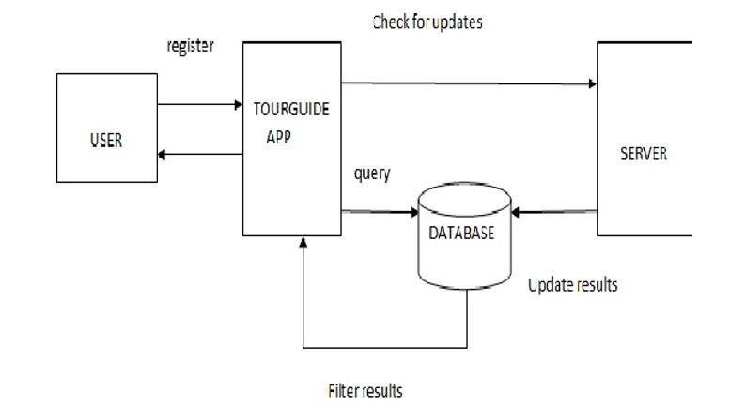

**ER-Diagram:**

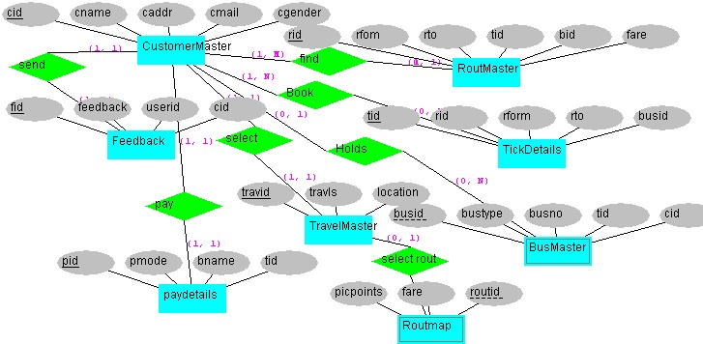

**Level 1 DFD for Administrator:**

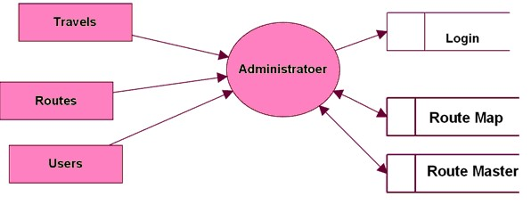

**Level 1 DFD for Users:**

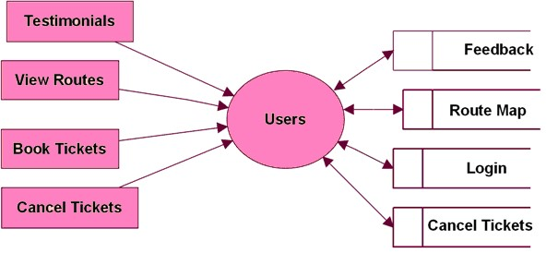

**Level 2 DFD for Travels:**

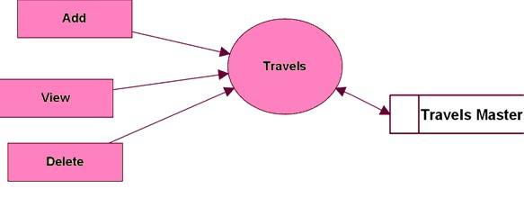

**Level 2 DFD for Routes:**

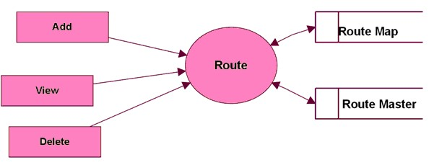

**Level 2 DFD for Pickup Points:**

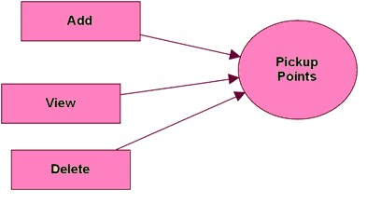

**Level 2 DFD for Booking Modules:**

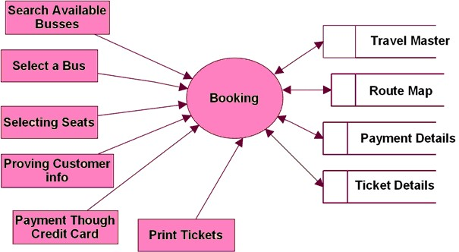

**Level 3 DFD for Testimonial:**

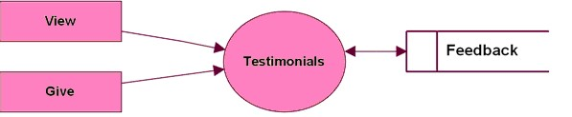

**Use case Diagram:**

Admin

Add

Route

View Routes

Delete Routes

Add Travel

View Travel

s

Delete Travels

Add Busses

View Busses

Add Pickup Points

View Pickup Points

Customer

Search For A Bus

View Seats

Availability

Book Tickets

Cancel Tickets

Feed Back

Testimonials

**Backend Diagrams:**

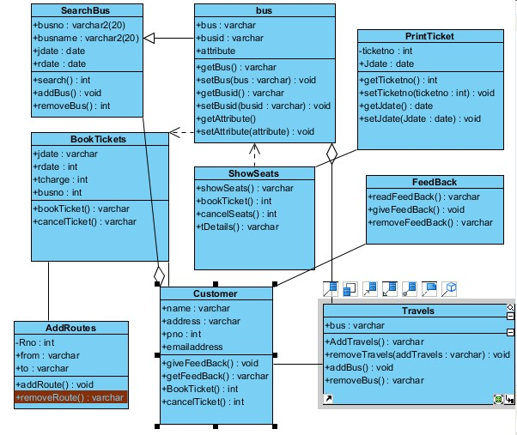

**6. IMPLEMENTATION**

**Database source code:-**

create table aadmin(adminEmail varchar2(60),adminpassword varchar2(30))

desc aadmin

select * from aadmin

insert into aadmin values('Suraj@gmail.com','Suraj@123')

insert into aadmin values('javascript@gmail.com','javascript')

insert into aadmin values('juhi@gmail.com','Juhi@gmail.com')

[create table adminlogin(adminemail varchar(20),adminpassword varchar(20))](javascript:sc_postHistory('732320118266271','SYSTEM');)

[insert into adminlogin values('juhi1@gmail.com','juhikarn')](javascript:sc_postHistory('732505011271293','SYSTEM');)

**HOME1.html:**

<html lang="en">

<head>

<title>Page title</title>

<meta charset="UTF-8">

<meta name="viewport" content="width=device-width,initial-scale=1">

<style>

body{

font-family:Arial;

margin:0;

}

.header {

padding: 10px;

background:white;

color: black;

font-size:30px;

}

.content{

padding: 0px;

border: #FFFF00;

border-width: 5px ;

border-style:solid;

}

.text-footer {

text-align: center;

padding: 30px 0;

font-family: 'Ubuntu', sans-serif;

display: flex;

justify-content: center;

color: black;

}

.dropbtn {

color: black;

font-size: 22px;

border: none;

}

.dropdown {

display: inline-block;

}

.dropdown-content {

display: none;

position: absolute;

background-color: #f1f1f1;

min-width: 100px;

box-shadow: 0px 20px 40px 0px rgba(0,0,0,0.2);

z-index: 1;

}

.dropdown-content a {

color: black;

padding: 80px 100px;

text-decoration: none;

display: block;

}

.dropdown-content a:hover {background-color: none;}

.dropdown:hover .dropdown-content {display: block;}

</style>

</head>

<body>

<div class="header">

<H1><table>

<tr>

<td>

<img src="image/pic2.png" style="width:220px;height:120px;">&nbsp;&nbsp;&nbsp;&nbsp;&nbsp;&nbsp;&nbsp;&nbsp;&nbsp;&nbsp;&nbsp;&nbsp;</td>

<td><a href="HOME1.html" style="text-decoration: none ;color:YELLOW;font-size:20px" > HOME |</a>&nbsp;&nbsp;&nbsp;</td>

<td><a href="MANAGEBOOK.html" style="text-decoration: none ;color:black;font-size:20px" > MANAGE BOOKINGS |</a>&nbsp;&nbsp;&nbsp;</td>

<td><a href="GALLERY.html" style="text-decoration: none ;color:black;font-size:20px" > GALLERY |</a>&nbsp;&nbsp;&nbsp;</td>

<td><a href="TRACK.html" style="text-decoration: none ;color:black;font-size:20px" > TRACK |</a>&nbsp;&nbsp;&nbsp;</td>

<td><a href="CONTACT.html" style="text-decoration: none ;color:black;font-size:20px" > CONTACT |</a>&nbsp;&nbsp;&nbsp;</td>

<td><a href="aboutus.html" style="text-decoration: none ;color:black;font-size:20px" > ABOUT US |</a>&nbsp;&nbsp;&nbsp;</td>

<td><a href="help.html" style="text-decoration: none ;color:black;font-size:20px" >HELP |</a>&nbsp;&nbsp;&nbsp;</td>

<td><a href="logout.html" style="text-decoration: none ;color:black;font-size:20px" > LOGOUT | </a></td>

<td>

<div class="dropdown">

<button class="dropbtn">LOGIN</button>

<div class="dropdown-content">

<form action="admin.html">

<center><button type="submit">Admin login</button></center>

</form>

<form action="user.html">

<center><button type="submit">User login</button></center>

</form>

</div>

</div>

</td>

</tr>

</table>

</H1>

</div>

<div class="content">

<img src="image/pic1.jpg" style="width:1514px;height:600px;">

</div>

<footer class="background">

<p class="text-footer">

Copyright ©-All rights are reserved

</p>

</footer>

</body>

</html>

**Contact.html:**

<html lang="en">

<head>

<title>Page title</title>

<meta charset="UTF-8">

<meta name="viewport" content="width=device-width,initial-scale=1">

<style>

body{

font-family:Arial;

margin:0;

}

.header {

padding: 10px;

background:white;

color: black;

font-size:30px;

}

.content{

padding: 0px;

background-color:#D3D3D3;

border: #FFFF00;

border-width: 5px 1px;

border-style:solid;

}

.text-footer {

text-align: center;

padding: 30px 0;

font-family: 'Ubuntu', sans-serif;

display: flex;

justify-content: center;

color: black;

}

.dropbtn {

color: black;

font-size: 22px;

border: none;

}

.dropdown {

display: inline-block;

}

.dropdown-content {

display: none;

position: absolute;

background-color: #f1f1f1;

min-width: 90px;

box-shadow: 0px 8px 16px 0px rgba(0,0,0,0.2);

z-index: 1;

}

.dropdown-content a {

color: black;

padding: 14px 16px;

text-decoration: none;

display: block;

}

.dropdown-content a:hover {background-color: none;}

.dropdown:hover .dropdown-content {display: block;}

</style>

</head>

<body>

<div class="header">

<H1><table><tr><td>

<img src="image/pic2.png" style="width:220px;height:120px;">&nbsp;&nbsp;&nbsp;&nbsp;&nbsp;&nbsp;&nbsp;&nbsp;&nbsp;&nbsp;&nbsp;&nbsp;</td>

<td><a href="HOME1.html" style="text-decoration: none ;color:YELLOW;font-size:20px" > HOME |</a>&nbsp;&nbsp;&nbsp;</td>

<td><a href="magagebook.html" style="text-decoration: none ;color:black;font-size:20px" > MANAGE BOOKINGS |</a>&nbsp;&nbsp;&nbsp;</td>

<td><a href="GALLERY.html" style="text-decoration: none ;color:black;font-size:20px" > GALLERY |</a>&nbsp;&nbsp;&nbsp;</td>

<td><a href="TRACK.html" style="text-decoration: none ;color:black;font-size:20px" > TRACK |</a>&nbsp;&nbsp;&nbsp;</td>

<td><a href="CONTACT.html" style="text-decoration: none ;color:black;font-size:20px" > CONTACT |</a>&nbsp;&nbsp;&nbsp;</td>

<td><a href="aboutus.html" style="text-decoration: none ;color:black;font-size:20px" > ABOUT US |</a>&nbsp;&nbsp;&nbsp;</td>

<td><a href="help.html" style="text-decoration: none ;color:black;font-size:20px" >HELP |</a>&nbsp;&nbsp;&nbsp;</td>

<td><a href="logout.html" style="text-decoration: none ;color:black;font-size:20px" > LOGOUT | </a></td>

<td>

<div class="dropdown">

<button class="dropbtn">LOGIN</button>

<div class="dropdown-content">

<form action="admin.html">

<center><button type="submit">Admin login</button></center>

</form>

<form action="user.html">

<center><button type="submit">User login</button></center>

</form>

</div>

</div>

</td>

</tr>

</table>

</H1>

<div class="content">

<table><tr><td>

<h2 class="page_title"> Contact Us</h2>

<div class="contact_detail">

<ul class="contact-info">

<li class="office"> <p>Corporate Office</p></li>

<li> <p>

<b>Vignan University,vadlamudi</b><br>

Tenali,

Guntur,<br/>

Andhrapradesh-522213</p></li>

<li class="phone"><p><i class="fa fa-phone fa-fw"></i>9142074956, 9441490483</p></li>

<li><p><i class="fa fa-envelope fa-fw"></i><a href="mailto:support@spbus.in" target="_blank">support@spbus.in</a></p></li>

</ul>

</div>

</td>

<td>state:<select name="forma" onchange="location = this.value;">

<option>chhaisgarh</option>

<option>bengal</option>

<option>karnataka</option>

<option>tamilnadu</option>

<option>bihar</option>

<option>telangana</option>

<option>jammu kashmir</option>

<option>ladakh</option>

<option>Himachal pradesh</option>

<option>uttrakhand</option>

<option>punjab</option>

<option>Hariyana</option>

<option>rajsthan</option>

<option>madhyapradesh</option>

<option>Uttarpradesh</option>

<option value="delhi.html">Delhi</option>

<option>jharkhand</option>

<option>Assam</option>

<option>Arunachal pradesh</option>

<option>Manipur</option>

<option>Meghalaya</option>

<option>mizoram</option>

<option>nagaland</option>

<option>odisha</option>

<option>sikkim</option>

<option>tamilnadu</option>

<option>gujrat</option>

<option>tripura</option>

<option>maharastra</option>

<option>kerala</option>

<option selected>Andhrapradesh</option>

</select> <br>

</td>

</tr>

</table>

</div>

<footer class="background">

<p class="text-footer">

Copyright ©-All rights are reserved

</p>

</footer>

</body>

</html>

**Gallery.html:**

<html lang="en">

<head>

<title>Page title</title>

<meta charset="UTF-8">

<meta name="viewport" content="width=device-width,initial-scale=1">

<style>

body{

font-family:Arial;

margin:0;

}

.header {

padding: 10px;

background:white;

color: black;

font-size:30px;

}

.content{

padding: 0px;

background-color:#D3D3D3;

border: #FFFF00;

border-width: 5px 1px;

border-style:solid;

}

.text-footer {

text-align: center;

padding: 30px 0;

font-family: 'Ubuntu', sans-serif;

display: flex;

justify-content: center;

color: black;

}

.dropbtn {

color: black;

font-size: 22px;

border: none;

}

.dropdown {

display: inline-block;

}

.dropdown-content {

display: none;

position: absolute;

background-color: #f1f1f1;

min-width: 90px;

box-shadow: 0px 8px 16px 0px rgba(0,0,0,0.2);

z-index: 1;

}

.dropdown-content a {

color: black;

padding: 14px 16px;

text-decoration: none;

display: block;

}

.dropdown-content a:hover {background-color: none;}

.dropdown:hover .dropdown-content {display: block;}

</style>

</head>

<body>

<div class="header">

<H1><table><tr><td>

<img src="image/pic2.png" style="width:220px;height:120px;">&nbsp;&nbsp;&nbsp;&nbsp;&nbsp;&nbsp;&nbsp;&nbsp;&nbsp;&nbsp;&nbsp;&nbsp;</td>

<td><a href="HOME1.html" style="text-decoration: none ;color:YELLOW;font-size:20px" > HOME |</a>&nbsp;&nbsp;&nbsp;</td>

<td><a href="magagebook.html" style="text-decoration: none ;color:black;font-size:20px" > MANAGE BOOKINGS |</a>&nbsp;&nbsp;&nbsp;</td>

<td><a href="GALLERY.html" style="text-decoration: none ;color:black;font-size:20px" > GALLERY |</a>&nbsp;&nbsp;&nbsp;</td>

<td><a href="TRACK.html" style="text-decoration: none ;color:black;font-size:20px" > TRACK |</a>&nbsp;&nbsp;&nbsp;</td>

<td><a href="CONTACT.html" style="text-decoration: none ;color:black;font-size:20px" > CONTACT |</a>&nbsp;&nbsp;&nbsp;</td>

<td><a href="aboutus.html" style="text-decoration: none ;color:black;font-size:20px" > ABOUT US |</a>&nbsp;&nbsp;&nbsp;</td>

<td><a href="help.html" style="text-decoration: none ;color:black;font-size:20px" >HELP |</a>&nbsp;&nbsp;&nbsp;</td>

<td><a href="logout.html" style="text-decoration: none ;color:black;font-size:20px" > LOGOUT | </a></td>

<!DOCTYPE html>

<td>

<div class="dropdown">

<button class="dropbtn">LOGIN</button>

<div class="dropdown-content">

<form action="admin.html">

<center><button type="submit">Admin login</button></center>

</form>

<form action="user.html">

<center><button type="submit">User login</button></center>

</form>

</div>

</div>

</td>

</tr>

</table>

</H1>

<div class="content">

<table>

<tr>

<th>Speed</th>

<th>Safety</th>

<th>Comfort</th>

</tr>

<tr>

<td>&nbsp;&nbsp;&nbsp;&nbsp;&nbsp;&nbsp;&nbsp;&nbsp;<a href="#"> <img src="image/bus1.png" style="width:400px;height:300px;"> </a>&nbsp;&nbsp;&nbsp;&nbsp;&nbsp;&nbsp;&nbsp;&nbsp;&nbsp;&nbsp;&nbsp;&nbsp;&nbsp;&nbsp;&nbsp;&nbsp;&nbsp;&nbsp;&nbsp;&nbsp;&nbsp;&nbsp;</td>

<td><a href="#"> <img src="image/bus2.png" style="width:400px;height:300px;"> </a>&nbsp;&nbsp;&nbsp;&nbsp;&nbsp;&nbsp;&nbsp;&nbsp;&nbsp;&nbsp;&nbsp;&nbsp;&nbsp;&nbsp;&nbsp;&nbsp;&nbsp;&nbsp;&nbsp;&nbsp;&nbsp;&nbsp;</td>

<td><a href="#"> <img src="image/bus3.png" style="width:400px;height:300px;"> </a>

</td>

</tr>

</table>

</div>

<footer class="background">

<p class="text-footer">

Copyright ©-All rights are reserved

</p>

</footer>

</body>

</html>

**Managebook.html:**

<html lang="en">

<head>

<title>Page title</title>

<meta charset="UTF-8">

<meta name="viewport" content="width=device-width,initial-scale=1">

<style>

body{

font-family:Arial;

margin:0;

}

.header {

padding: 10px;

background:white;

color: black;

font-size:30px;

}

.text-footer {

text-align: center;

padding: 30px 0;

font-family: 'Ubuntu', sans-serif;

display: flex;

justify-content: center;

color: black;

}

.dropbtn {

color: black;

font-size: 22px;

border: none;

}

.dropdown {

display: inline-block;

}

.dropdown-content {

display: none;

position: absolute;

background-color: #f1f1f1;

min-width: 90px;

box-shadow: 0px 8px 16px 0px rgba(0,0,0,0.2);

z-index: 1;

}

.dropdown-content a {

color: black;

padding: 14px 16px;

text-decoration: none;

display: block;

}

.dropdown-content a:hover {background-color: none;}

.dropdown:hover .dropdown-content {display: block;}

* {

box-sizing: border-box;

}

/* Style inputs */

input[type=text], select, textarea {

width: 50%;

padding: 12px;

border: 1px solid #ccc;

margin-top: 6px;

margin-bottom: 16px;

resize: vertical;

}

input[type=submit] {

background-color:yellow;

color: black;

padding: 12px 20px;

border: none;

cursor: pointer;

}

input[type=submit]:hover {

background-color: black;

}

/* Style the container/contact section */

.container {

border-radius: 5px;

background-color: #f2f2f2;

padding: 5px;

border: #FFFF00;

border-width: 5px 1px;

border-style:solid;

}

/* Clear floats after the columns */

.row:after {

content: "";

display: table;

clear: both;

}

.column {

width: 50%;

margin-top: 6px;

padding: 20px;

}

/* Responsive layout - when the screen is less than 600px wide, make the two columns stack on top of each other instead of next to each other */

@media screen and (max-width: 600px) {

.column, input[type=submit] {

width: 100%;

margin-top: 0;

}

}

</style>

</head>

<body>

<div class="header">

<H1><table><tr><td>

<img src="image/pic2.png" style="width:220px;height:120px;">&nbsp;&nbsp;&nbsp;&nbsp;&nbsp;&nbsp;&nbsp;&nbsp;&nbsp;&nbsp;&nbsp;&nbsp;</td>

<td><a href="HOME1.html" style="text-decoration: none ;color:YELLOW;font-size:20px" > HOME |</a>&nbsp;&nbsp;&nbsp;</td>

<td><a href="MANAGEBOOK.html" style="text-decoration: none ;color:black;font-size:20px" > MANAGE BOOKINGS |</a>&nbsp;&nbsp;&nbsp;</td>

<td><a href="GALLERY.html" style="text-decoration: none ;color:black;font-size:20px" > GALLERY |</a>&nbsp;&nbsp;&nbsp;</td>

<td><a href="TRACK.html" style="text-decoration: none ;color:black;font-size:20px" > TRACK |</a>&nbsp;&nbsp;&nbsp;</td>

<td><a href="CONTACT.html" style="text-decoration: none ;color:black;font-size:20px" > CONTACT |</a>&nbsp;&nbsp;&nbsp;</td>

<td><a href="aboutus.html" style="text-decoration: none ;color:black;font-size:20px" > ABOUT US |</a>&nbsp;&nbsp;&nbsp;</td>

<td><a href="help.html" style="text-decoration: none ;color:black;font-size:20px" >HELP |</a>&nbsp;&nbsp;&nbsp;</td>

<td><a href="logout.html" style="text-decoration: none ;color:black;font-size:20px" > LOGOUT | </a></td>

<td>

<div class="dropdown">

<button class="dropbtn">LOGIN</button>

<div class="dropdown-content">

<form action="admin.html">

<center><button type="submit">Admin login</button></center>

</form>

<form action="user.html">

<center><button type="submit">User login</button></center>

</form>

</div>

</div>

</td>

</tr>

</table>

</H1>

<div class="container">

<div class="column">

<h2 style="color:black;">Manage Bookings</h2>

</div>

<div class="row">

<form action="/action_page.php">

<input type="text" id="fname" name="firstname" placeholder="Ticket Number">

<input type="text" id="lname" name="lastname" placeholder="Email or Phone Number"><br>

<input type="submit" value="Submit">

</form>

</div>

</div>

</div>

<footer class="background">

<p class="text-footer">

Copyright ©-All rights are reserved

</p>

</footer>

</body>

</html>

**Track.html:**

<html lang="en">

<head>

<title>Page title</title>

<meta charset="UTF-8">

<meta name="viewport" content="width=device-width,initial-scale=1">

<style>

body{

font-family:Arial;

margin:0;

}

.header {

padding: 10px;

background:white;

color: black;

font-size:30px;

}

.text-footer {

text-align: center;

padding: 30px 0;

font-family: 'Ubuntu', sans-serif;

display: flex;

justify-content: center;

color: black;

}

.dropbtn {

color: black;

font-size: 22px;

border: none;

}

.dropdown {

display: inline-block;

}

.dropdown-content {

display: none;

position: absolute;

background-color: #f1f1f1;

min-width: 90px;

box-shadow: 0px 8px 16px 0px rgba(0,0,0,0.2);

z-index: 1;

}

.dropdown-content a {

color: black;

padding: 14px 16px;

text-decoration: none;

display: block;

}

.dropdown-content a:hover {background-color: none;}

.dropdown:hover .dropdown-content {display: block;}

* {

box-sizing: border-box;

}

/* Style inputs */

input[type=number], select, textarea {

width: 50%;

padding: 12px;

border: 1px solid #ccc;

margin-top: 6px;

margin-bottom: 16px;

resize: vertical;

}

input[type=submit] {

background-color:yellow;

color: black;

padding: 12px 20px;

border: none;

cursor: pointer;

}

input[type=submit]:hover {

background-color: black;

}

/* Style the container/contact section */

.container {

border-radius: 5px;

background-color: #f2f2f2;

padding: 5px;

border: #FFFF00;

border-width: 5px 1px;

border-style:solid;

}

/* Clear floats after the columns */

.row:after {

content: "";

display: table;

clear: both;

}

.column {

width: 50%;

margin-top: 6px;

padding: 20px;

}

/* Responsive layout - when the screen is less than 600px wide, make the two columns stack on top of each other instead of next to each other */

@media screen and (max-width: 600px) {

.column, input[type=submit] {

width: 100%;

margin-top: 0;

}

}

</style>

</head>

<body>

<div class="header">

<H1><table><tr><td>

<img src="image/pic2.png" style="width:220px;height:120px;">&nbsp;&nbsp;&nbsp;&nbsp;&nbsp;&nbsp;&nbsp;&nbsp;&nbsp;&nbsp;&nbsp;&nbsp;</td>

<td><a href="HOME1.html" style="text-decoration: none ;color:YELLOW;font-size:20px" > HOME |</a>&nbsp;&nbsp;&nbsp;</td>

<td><a href="magagebook.html" style="text-decoration: none ;color:black;font-size:20px" > MANAGE BOOKINGS |</a>&nbsp;&nbsp;&nbsp;</td>

<td><a href="GALLERY.html" style="text-decoration: none ;color:black;font-size:20px" > GALLERY |</a>&nbsp;&nbsp;&nbsp;</td>

<td><a href="TRACK.html" style="text-decoration: none ;color:black;font-size:20px" > TRACK |</a>&nbsp;&nbsp;&nbsp;</td>

<td><a href="CONTACT.html" style="text-decoration: none ;color:black;font-size:20px" > CONTACT |</a>&nbsp;&nbsp;&nbsp;</td>

<td><a href="aboutus.html" style="text-decoration: none ;color:black;font-size:20px" > ABOUT US |</a>&nbsp;&nbsp;&nbsp;</td>

<td><a href="help.html" style="text-decoration: none ;color:black;font-size:20px" >HELP |</a>&nbsp;&nbsp;&nbsp;</td>

<td><a href="logout.html" style="text-decoration: none ;color:black;font-size:20px" > LOGOUT | </a></td>

<td>

<div class="dropdown">

<button class="dropbtn">LOGIN</button>

<div class="dropdown-content">

<form action="admin.html">

<center><button type="submit">Admin login</button></center>

</form>

<form action="user.html">

<center><button type="submit">User login</button></center>

</form>

</div>

</div>

</td>

</tr>

</table>

</H1>

<div class="container">

<div class="column">

<h2 style="color:black;">Track Your Shipment</h2>

</div>

<div class="row">

<form action="/action_page.php">

<input type="number" id="fname" name="firstname" placeholder="Your Tracking Number"><br>

<input type="submit" value="Search">

</form>

</div>

</div>

</div>

<footer class="background">

<p class="text-footer">

Copyright ©-All rights are reserved

</p>

</footer>

</body>

</html>

**7.RESULTS**

**Screenshots:**

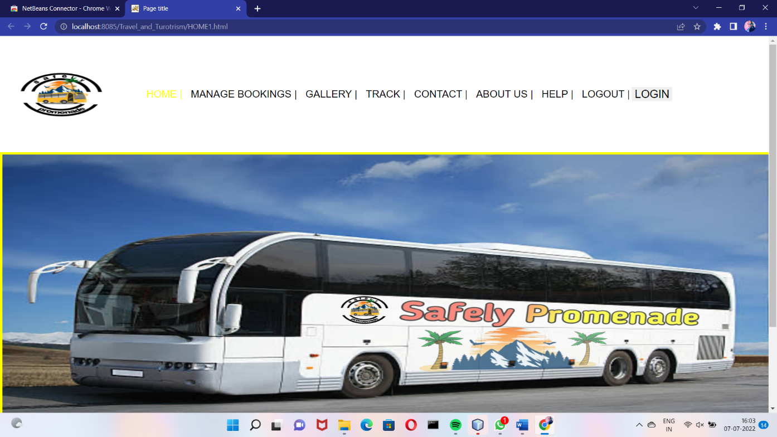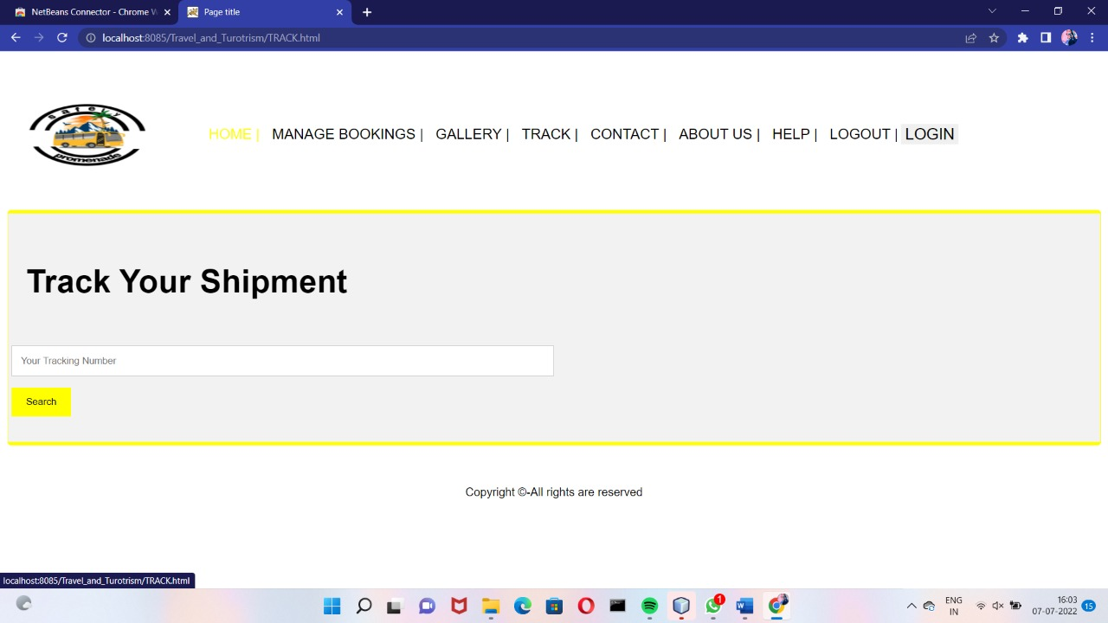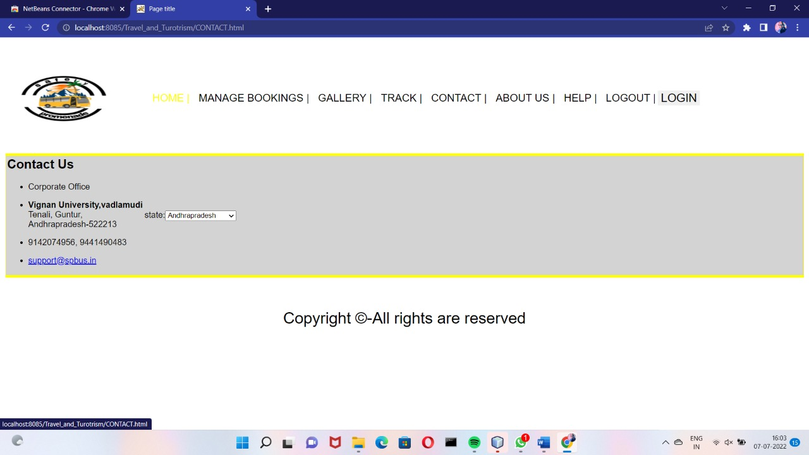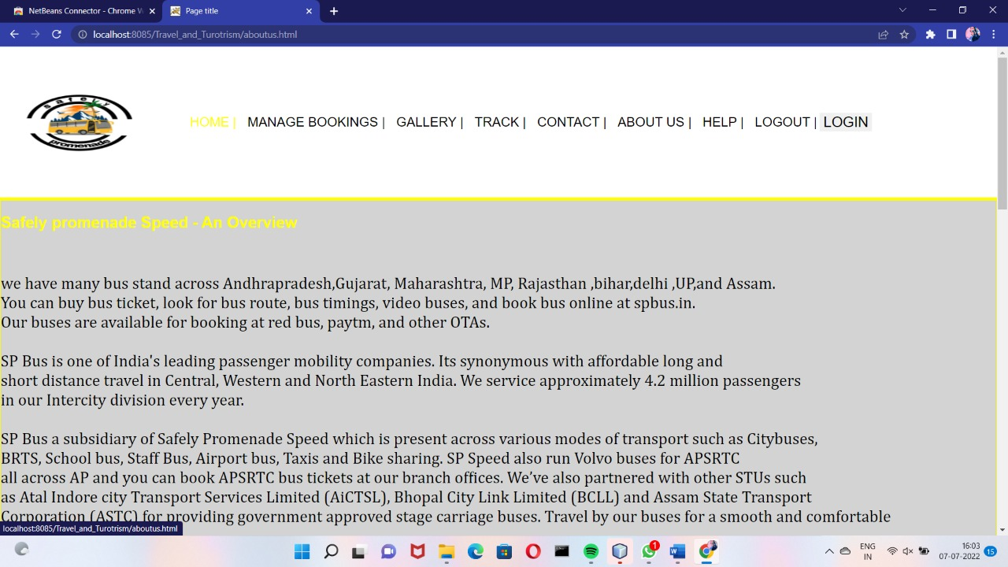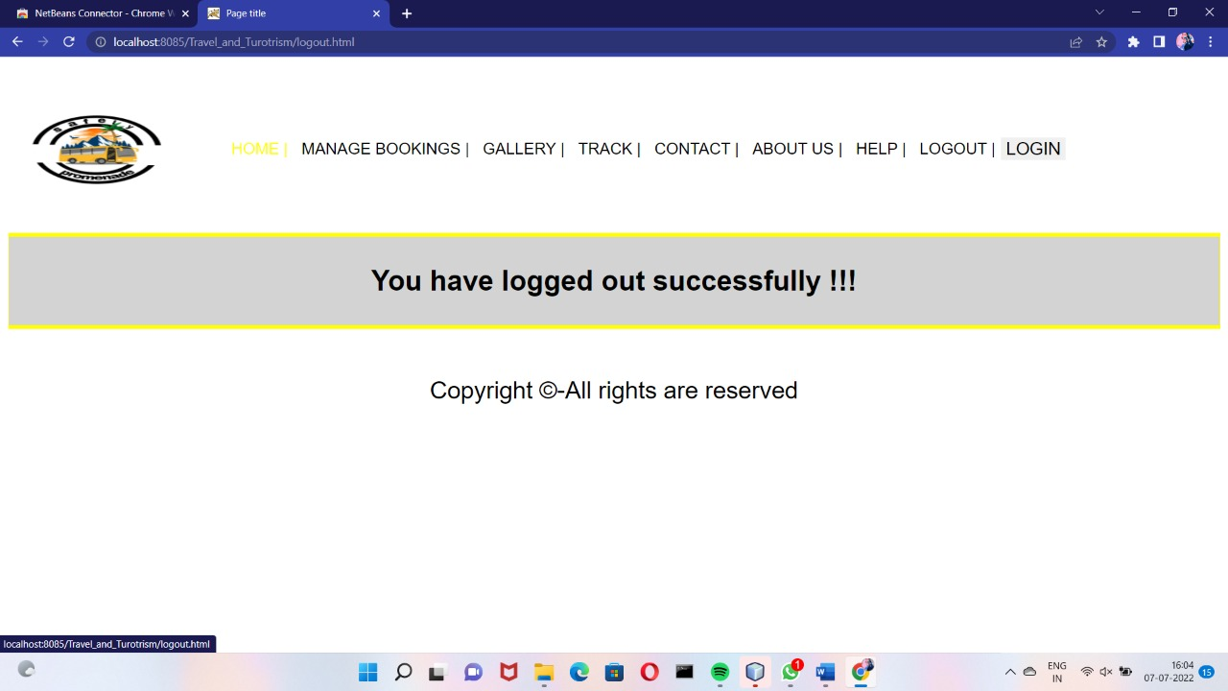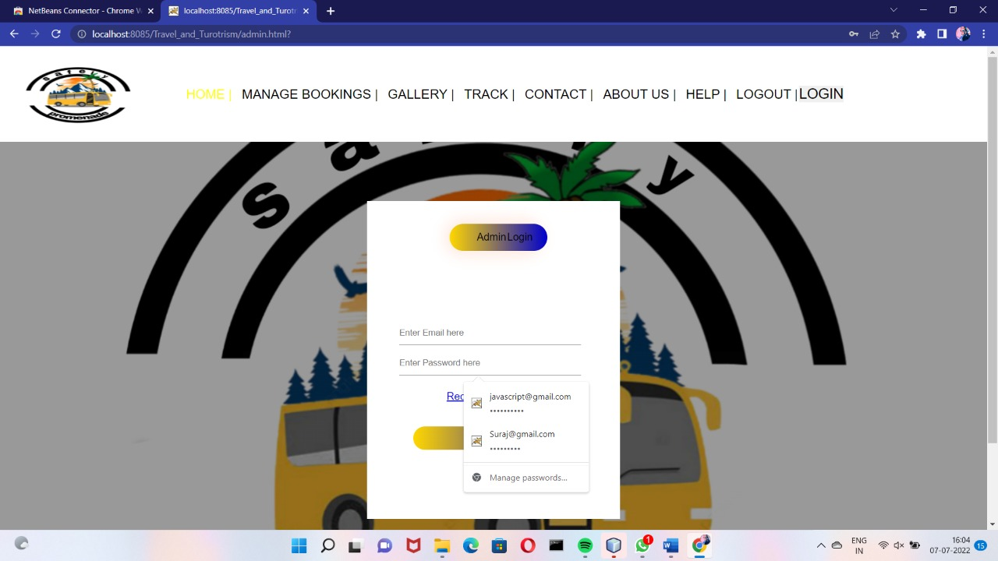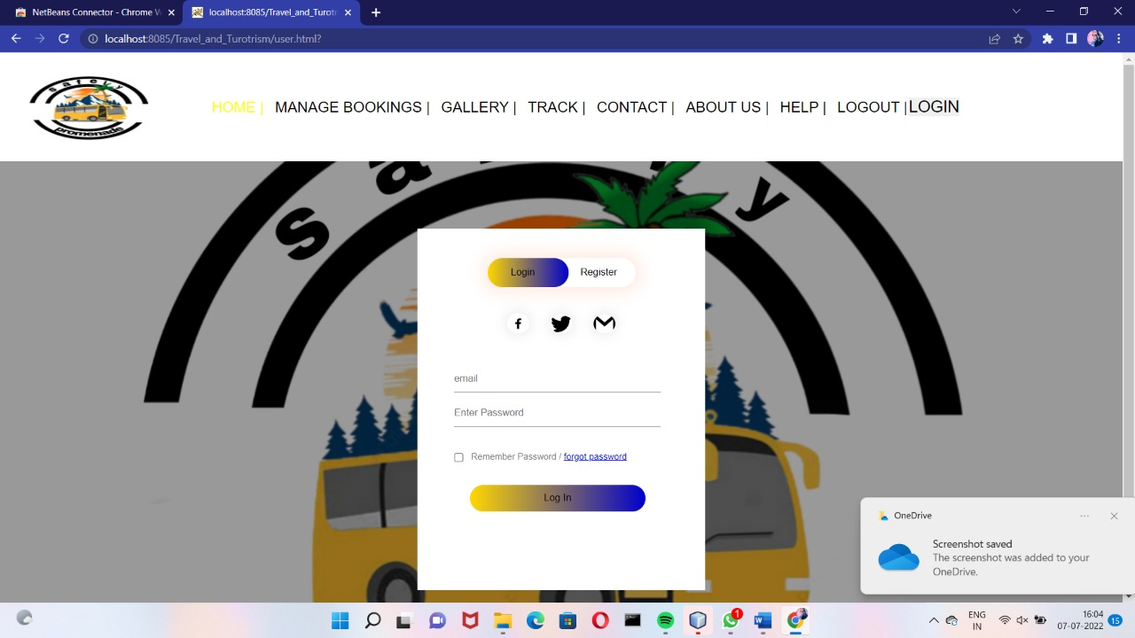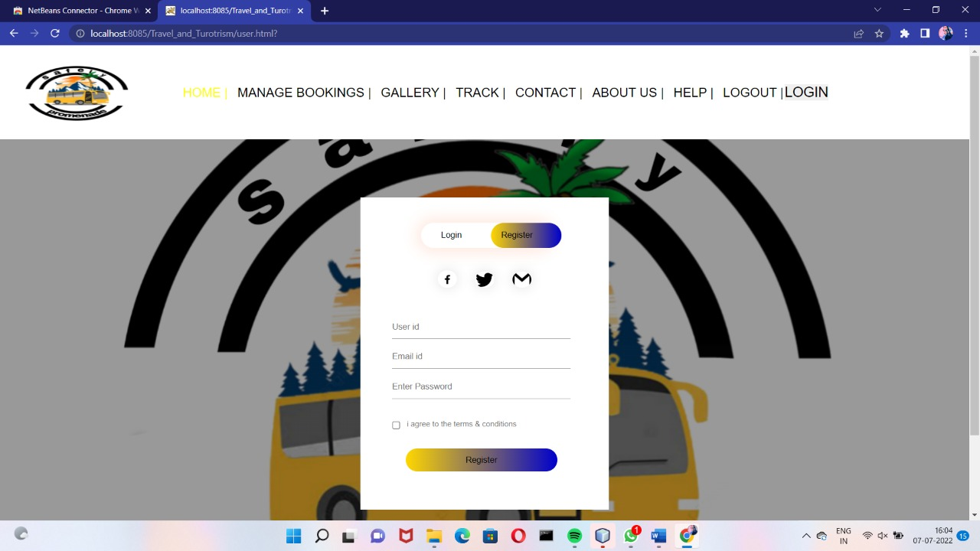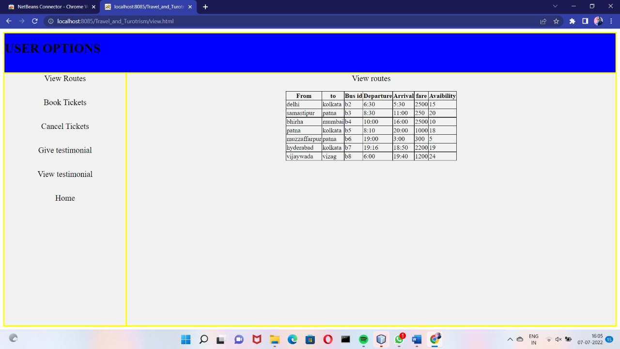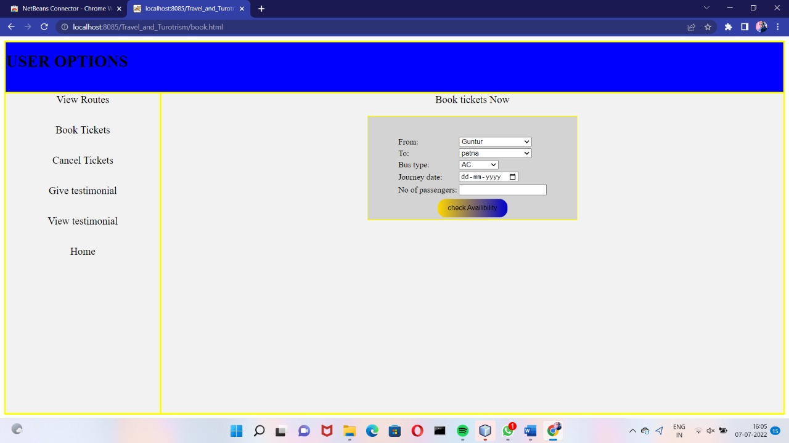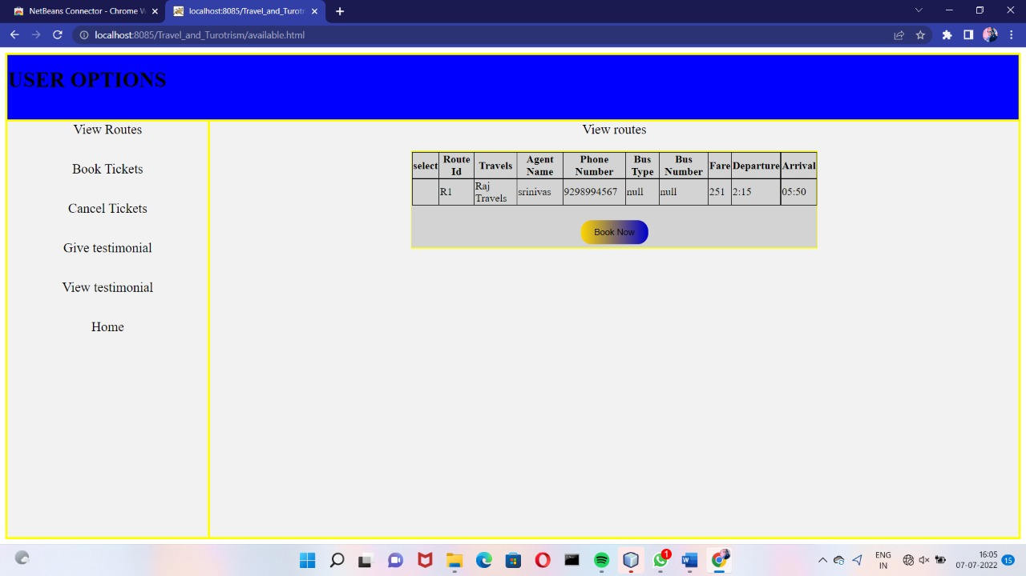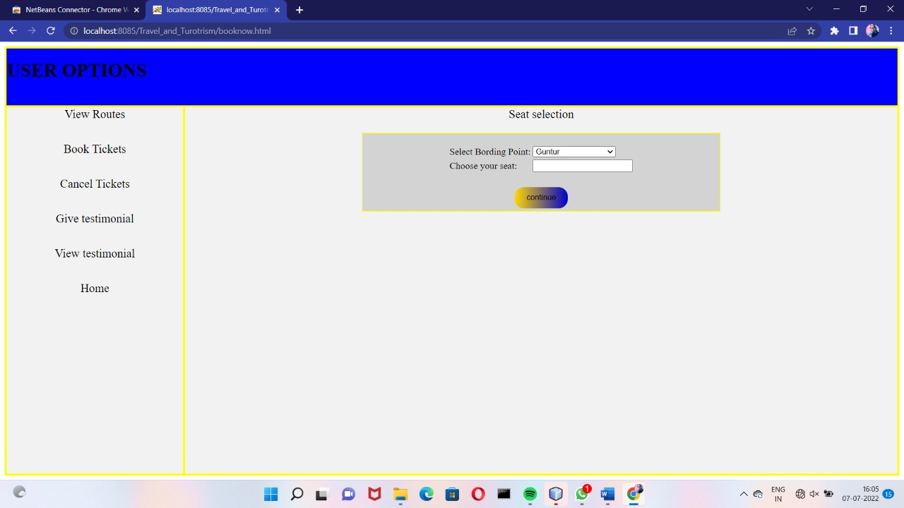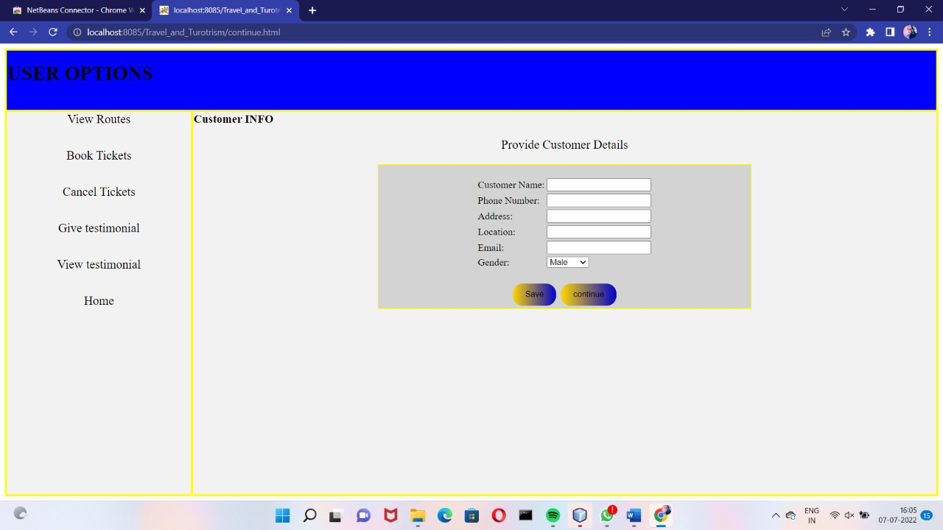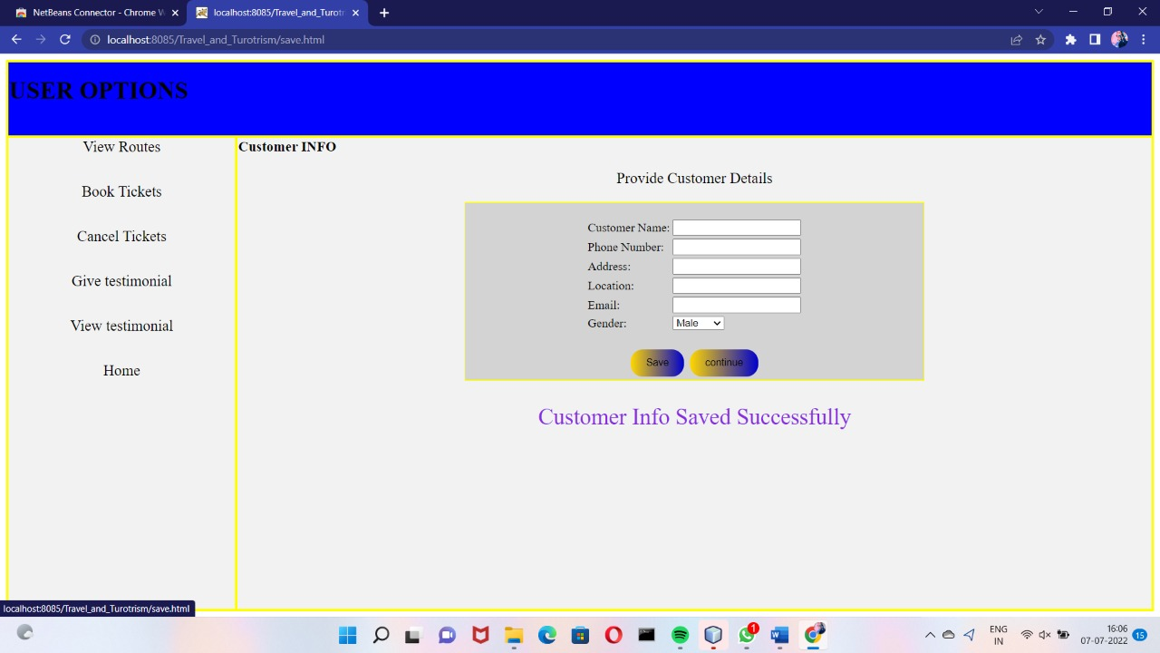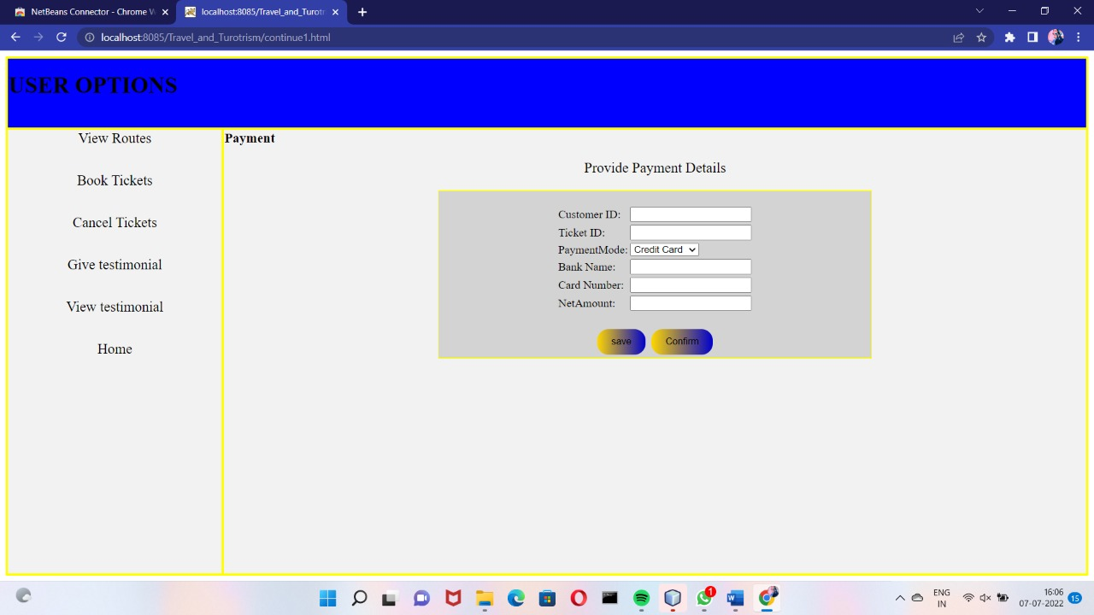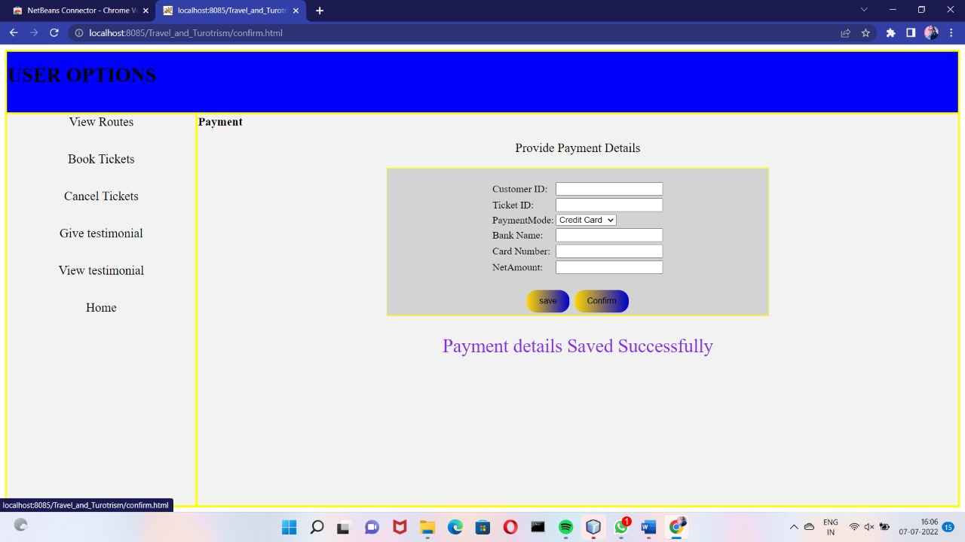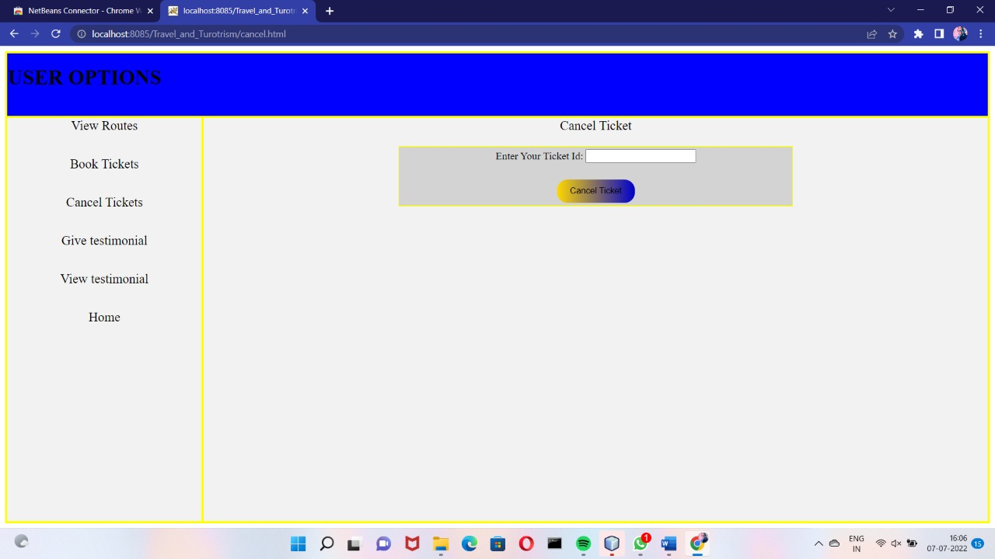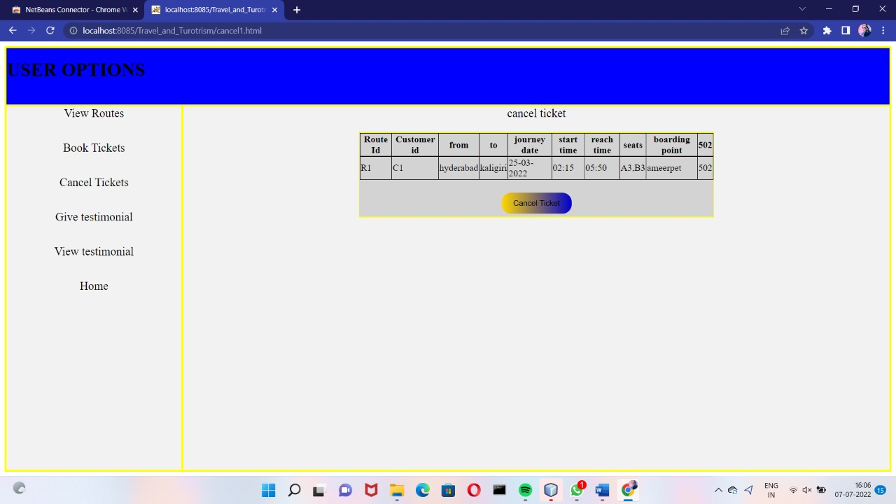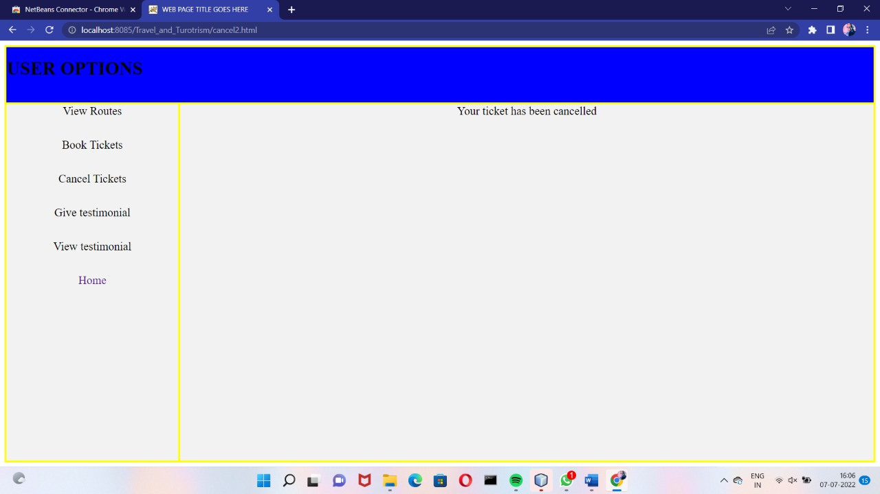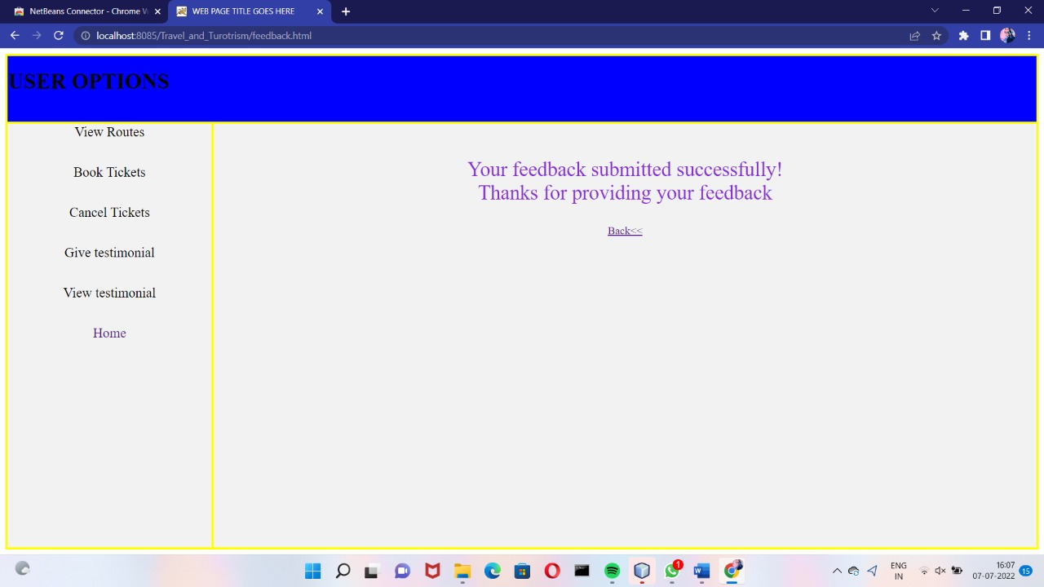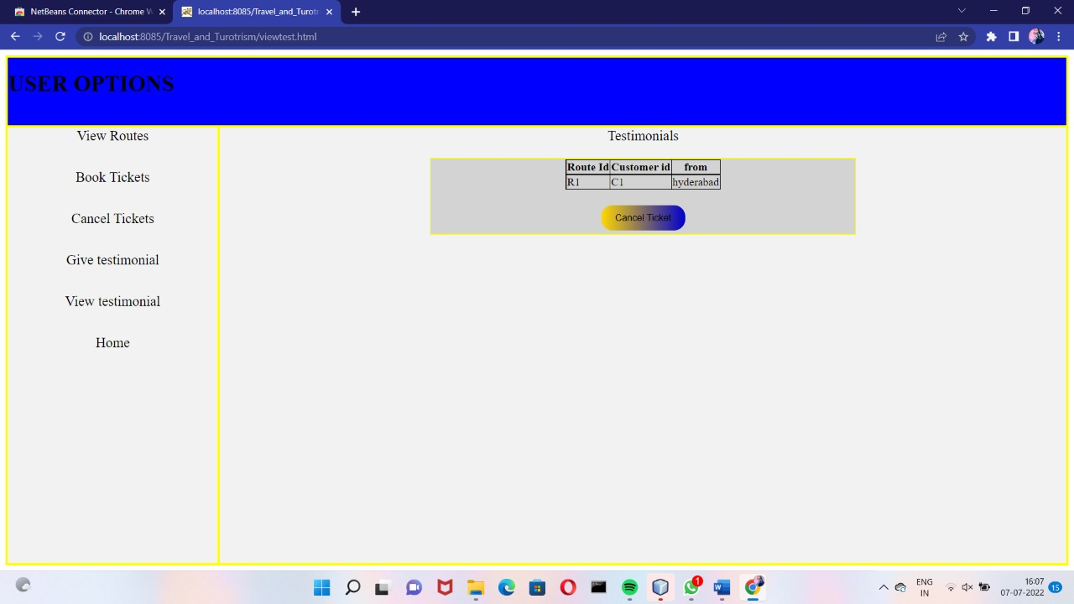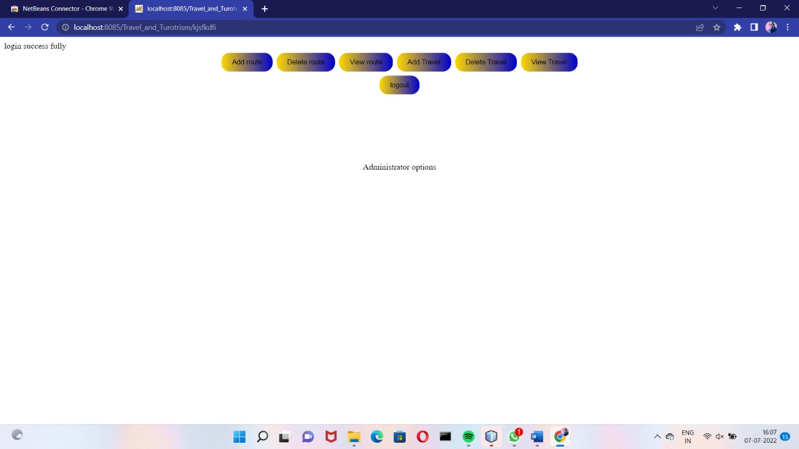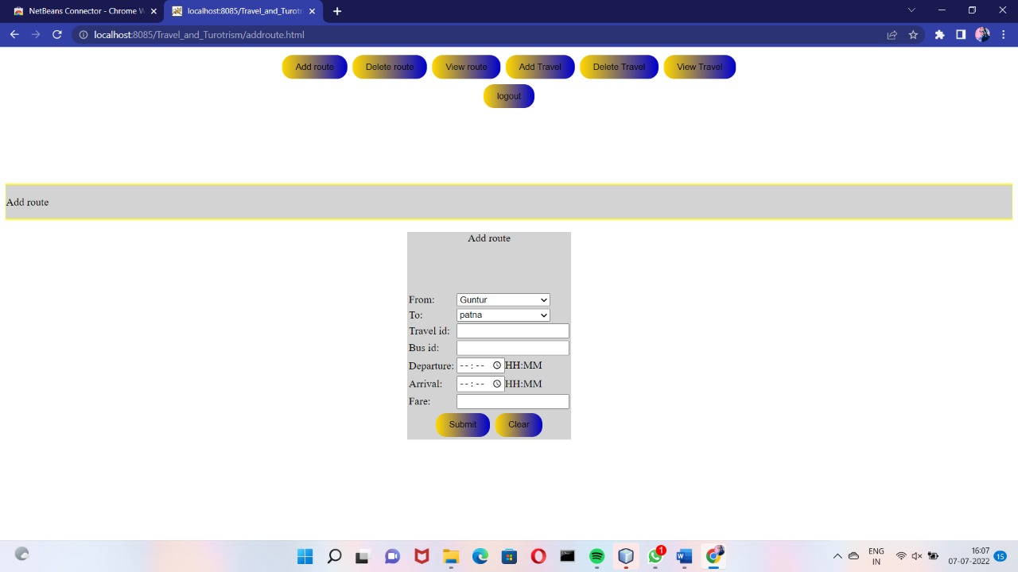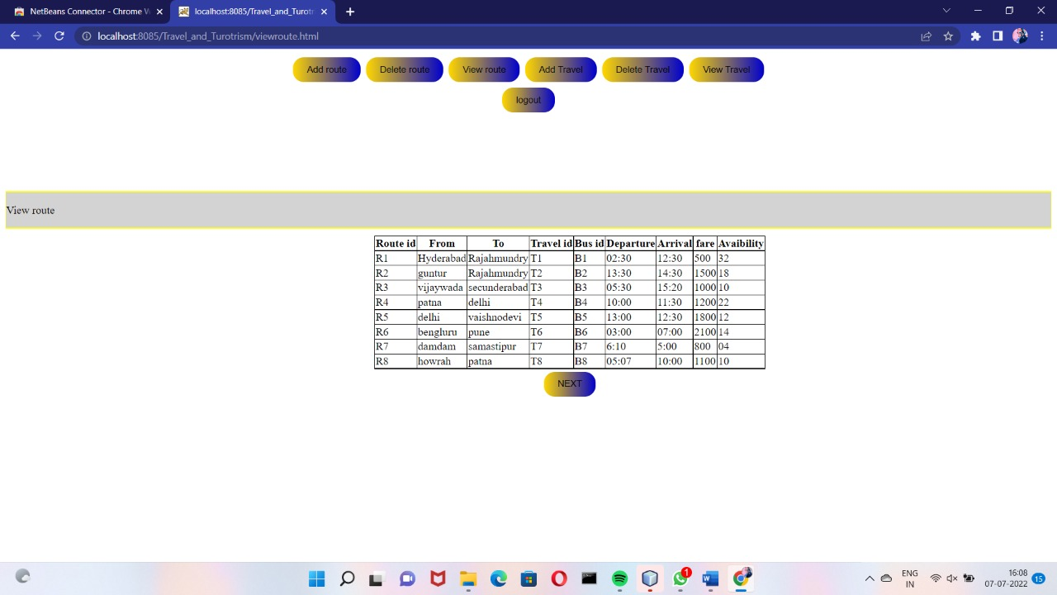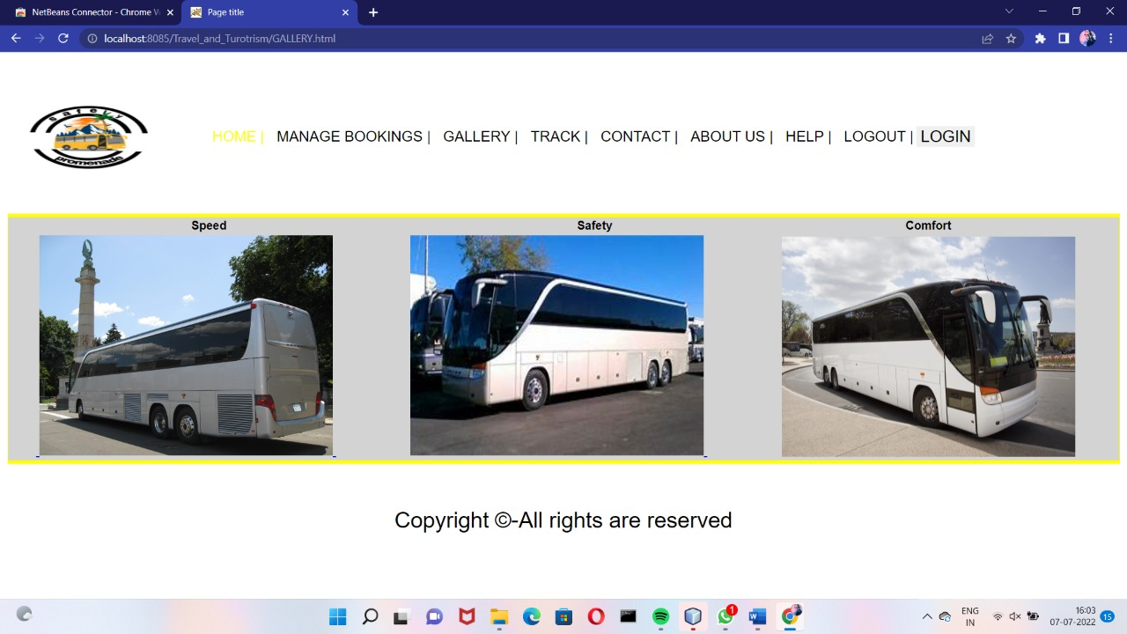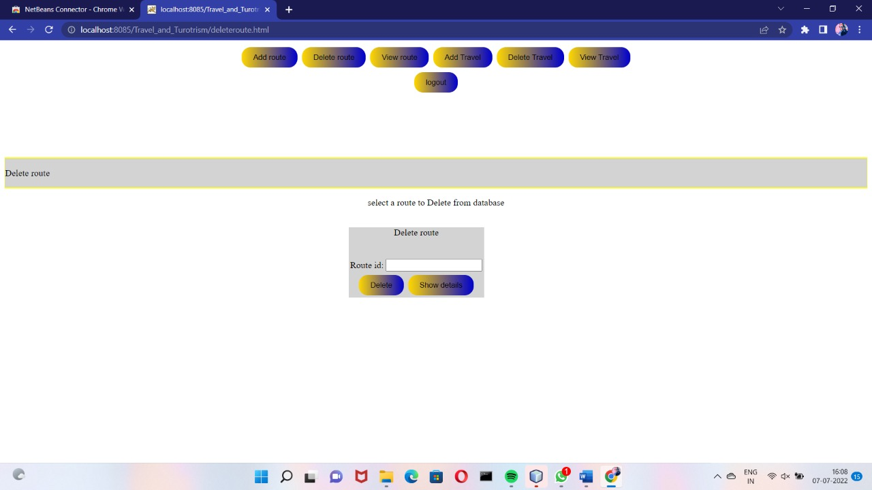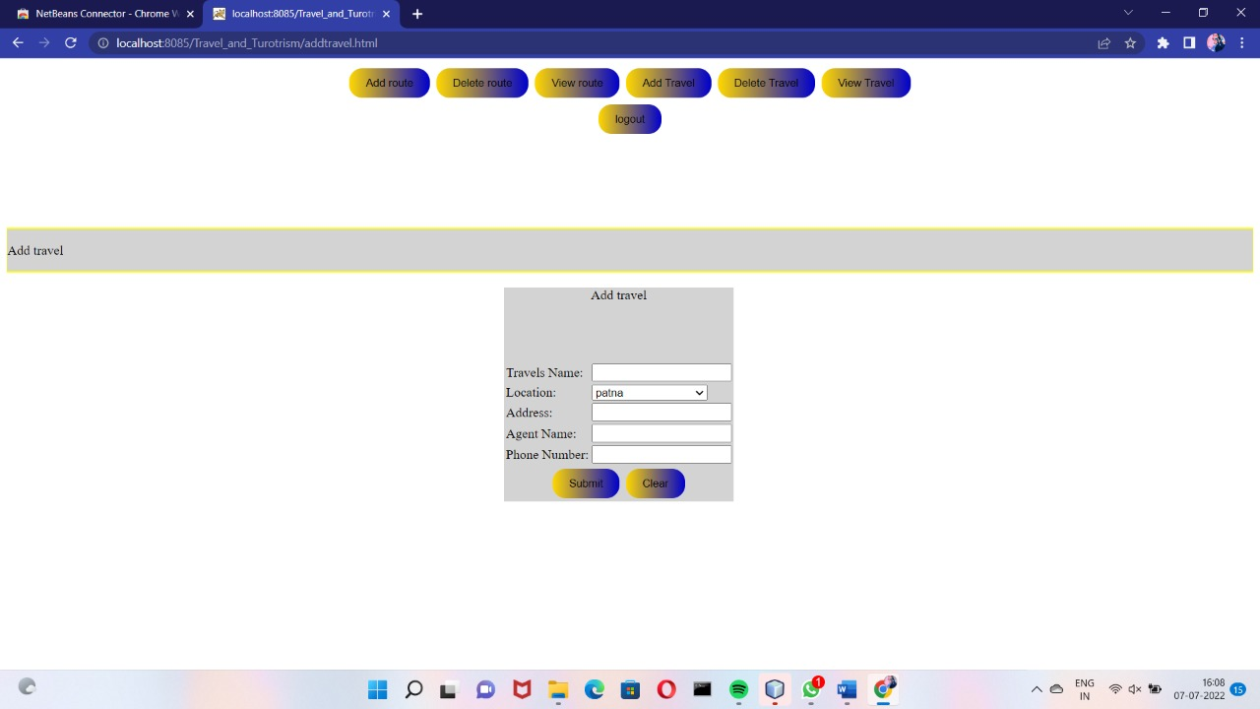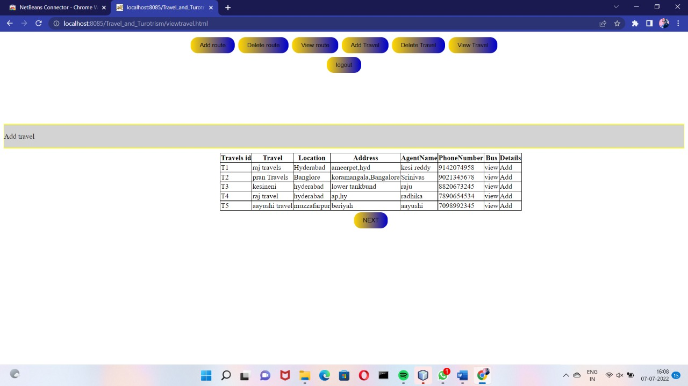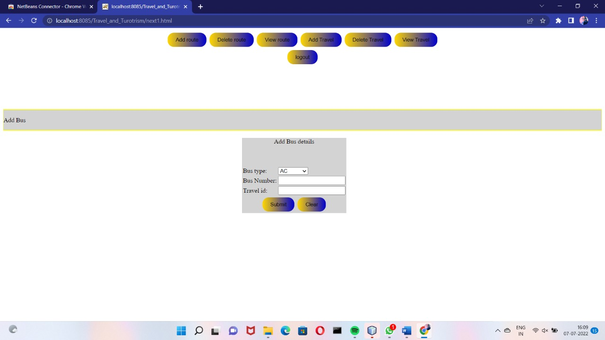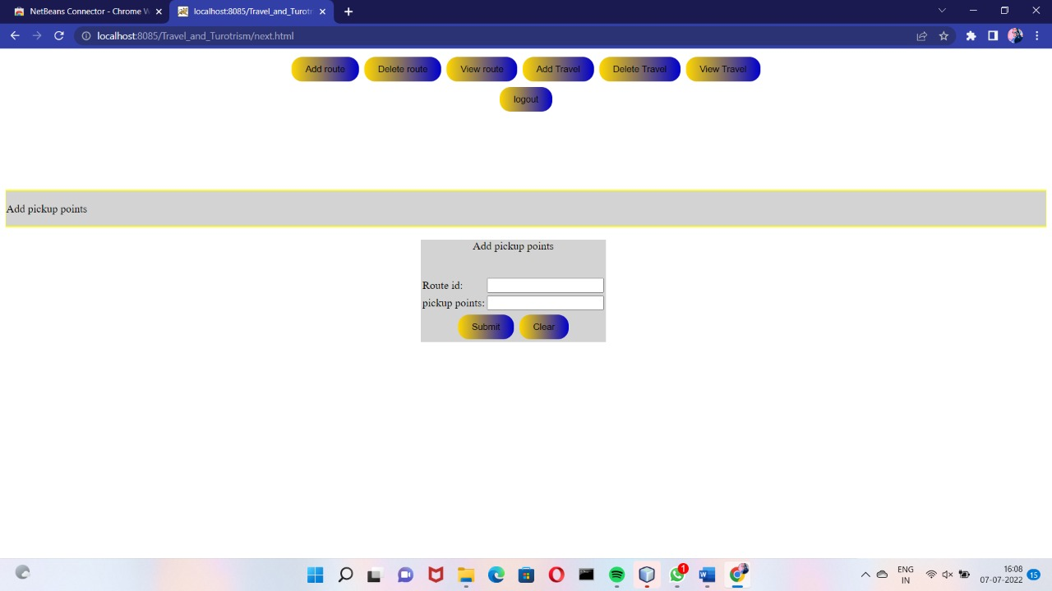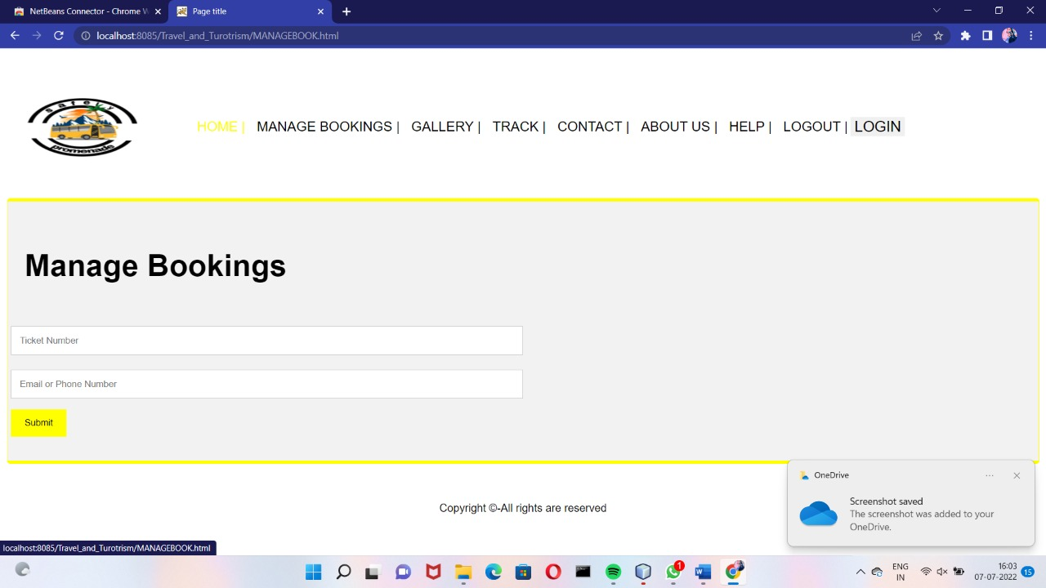

**8.TESTING**

**UNIT TESTING:**

The software units in a system are modules and routines that are assembled and integrated to perform a specific function. Unit testing focuses first on modules, independently of one another, to locate errors. This enables, to detect errors in coding and logic that are contained within each module. This testing includes entering data and ascertaining if the value matches to the type and size supported by java. The various controls are tested to ensure that each performs its action as required.

**INTEGRATION TESTING:**

Data can be lost across any interface, one module can have an adverse effect on another, sub functions when combined, may not produce the desired major functions. Integration testing is a systematic testing to discover errors associated within the interface. The objective is to take unit tested modules and build a program structure. All the modules are combined and tested as a whole. Here the Server module and Client module options are integrated and tested. This testing provides the assurance that the application is well integrated functional unit with smooth transition of data.

**9.CONCLUSION**

Travellers continue to seek authentic experiences. The tools they use to research and book these experiences are constantly changing due to innovations in technology. Destinations are also challenged by limited financial resources and strong competition for tourist dollars from other iconic and even lesser-known locations. The personalisation of travel suggests that independent travel will have a stronger presence than group travel, however, we must always consider the type of traveller. The travel services sector is being forced to innovate at a startling rate.

In the past, face to face consultations with a travel agent was paramount for booking both leisure and business travel. Technology and global circumstances, such as pandemics, financial collapses, and terrorism, have put pressure on tourism and travel services. With the development of OTAs and emerging and disruptive technologies, the travel services landscape is constantly changing.

“Travel and Tourism Management System” management process in travelling Fast processing and immediate results with high security Minimizing human effort and cost-efficient database Navigation through the site is very easy. The web site covers all the areas required for an including tourism.